CREATE DATABASE Frist_assigement_shailesh

CREATE TABLE Employee

(

EM_ID int AUTO_INCREMENT PRIMARY KEY,

FRIST_NAME VARCHAR(100)NOT NULL,

LAST_NAME VARCHAR(100) NOT NULL,

SALARY INT UNSIGNED NOT NULL,

JOINING_DATE DATE,

DEPARTMENT TEXT);

SINGLE INSERT QUERY:-

INSERT INTO employee

(EM_ID,FRIST_NAME,LAST_NAME,SALARY,JOINING_DATE,DEPARTMENT)

VALUES

(1,"SHAILESH","PRAJAPATI",20000,"1994-05-01","BANKING")

INSERT INTO employee

VALUES

("","CHIRAG","PARMAR",30000,"1991-01-20","INSURANCE"),

("","AKASH","PATEL",35000,"1995-08-26","SERVICES"),

("","SANDIP","SOLANKI",50000,"1998-09-06","INSURANCE"),

("","UPESH","PRAJAPATI",80000,"1990-11-12","BANKING"),

("","NIKHIL","PAREKH",90000,"1999-12-05","INSURANCE"),

("","KISHAN","THAKOR",95000,"1980-06-14","SERVICES"),

("","JOHN","ABRAHAM",85000,"1999-12-05","INSURANCE"),

("","ROY","THOMAS",100000,"2000-11-09","BANKING");

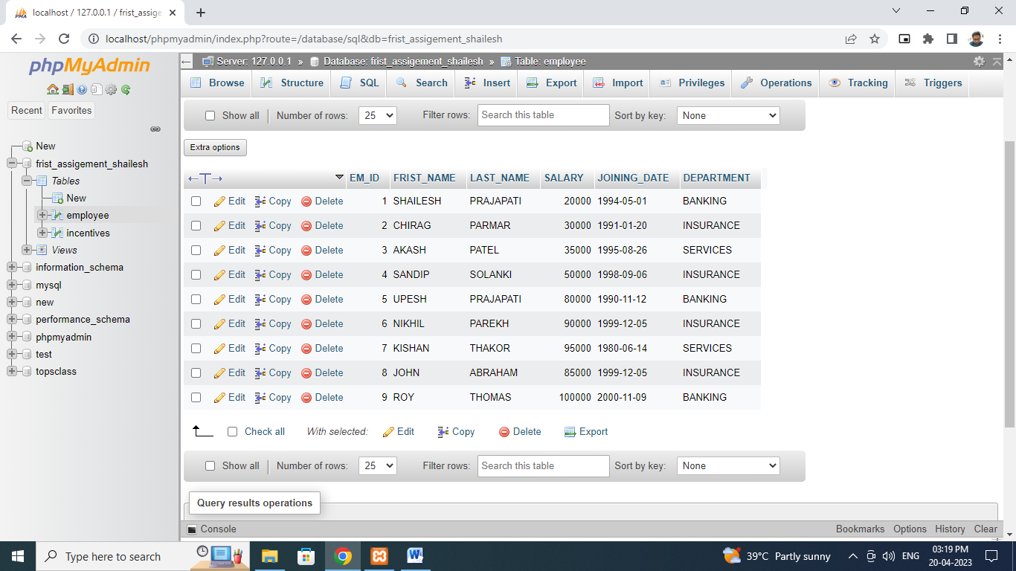

CREATE TABLE INCENTIVES(

INCENTIVE_ID INT NOT NULL UNIQUE,

EMPLOYEE_REF_ID INT NOT NULL UNIQUE,

INCENTIVE_DATE DATE,

INCENTIVE_AMT INT) ;

INSERT INTO incentives VALUES

(1,1,"2023-02-01",5000),

(2,3,"2023-01-01",3000),

(3,5,"2023-02-01",3500),

(4,2,"2023-01-01",2500),

(5,4,"2023-03-01",4000),

(6,8,"2023-02-01",4500),

(7,7,"2023-03-01",3000),

(8,6,"2023-02-01",2500),

(9,10,"2023-03-01",5000),

(10,9,"2023-02-01",3000);

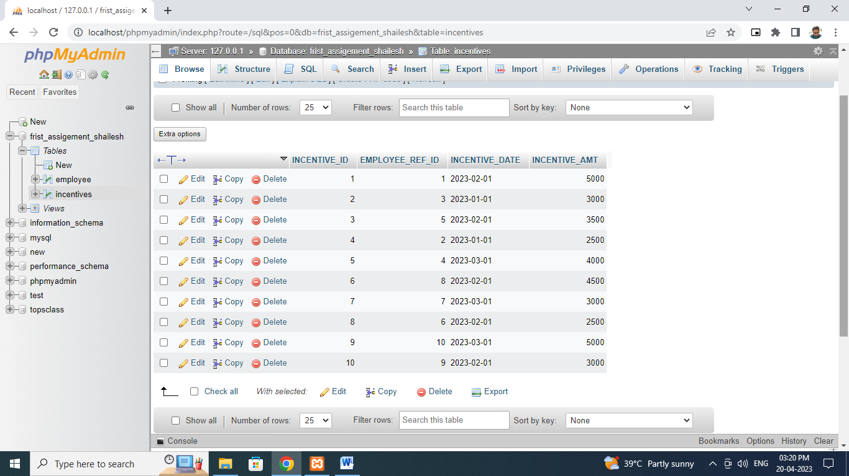

1 ) Get First_Name from employee table using alias name “Employee Name”.

SELECT FRIST_NAME AS EMPLOYEE_NAME FROM employee;

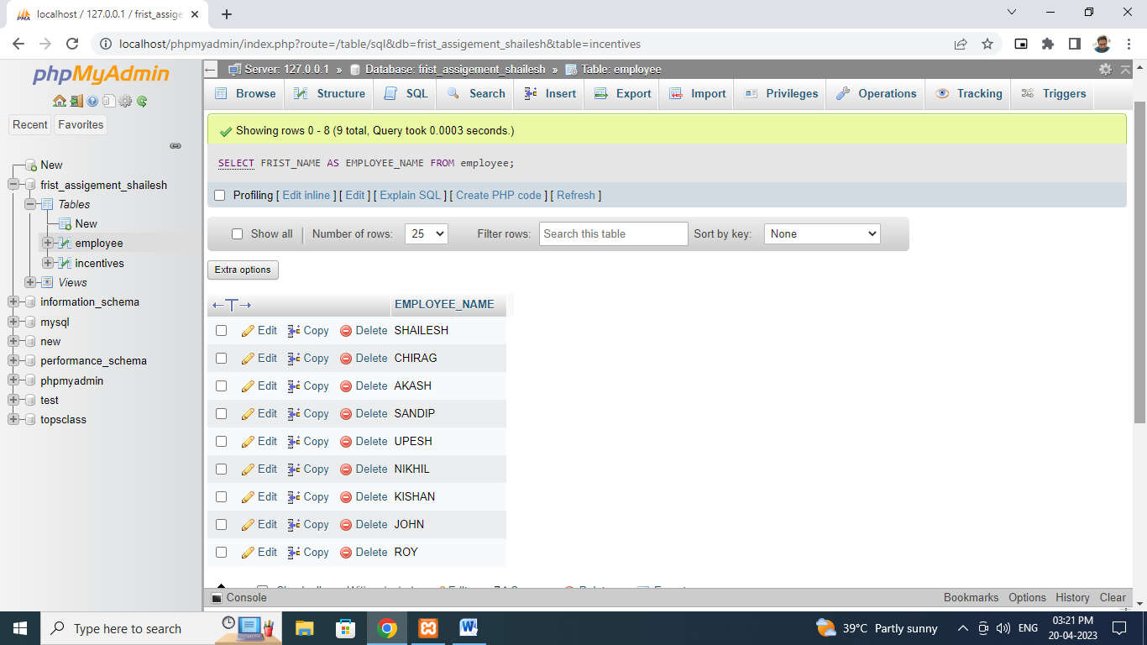

2) Get FIRST_NAME, Joining year, Joining Month and Joining Date from employee table.

SELECT FRIST_NAME,JOINING_DATE FROM employee;

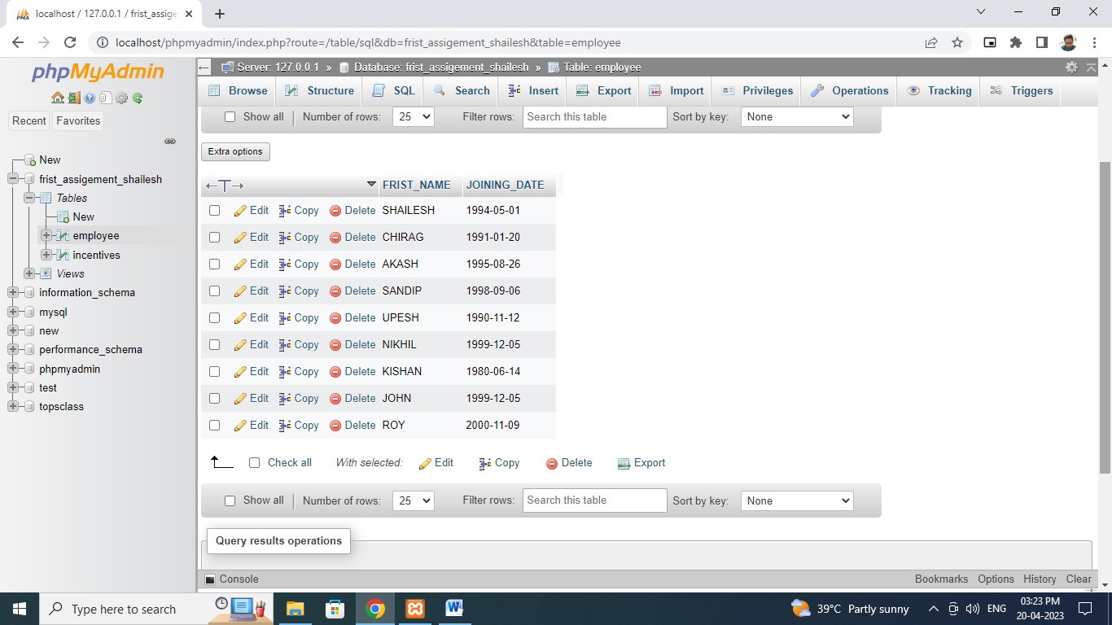

3) Get all employee details from the employee table order by First Name Ascending and Salary descending?

SELECT * FROM employee

ORDER BY FRIST_NAME ASC;

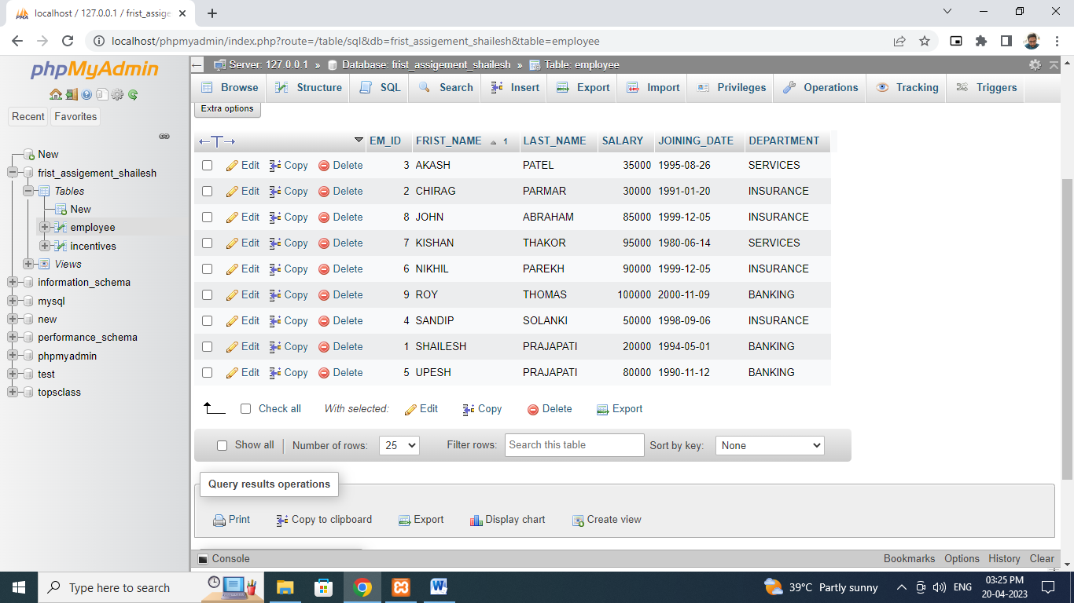

SELECT * FROM employee

ORDER BY SALARY DESC;

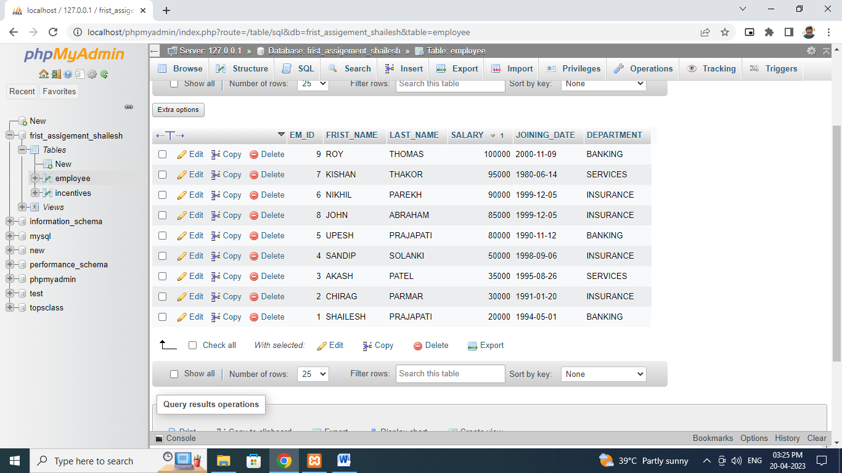

4) Get employee details from employee table whose first name contains „o‟.

SELECT FRIST_NAME FROM employee WHERE FRIST_NAME LIKE "%O%"

SELECT * FROM employee WHERE FRIST_NAME LIKE "%O%"

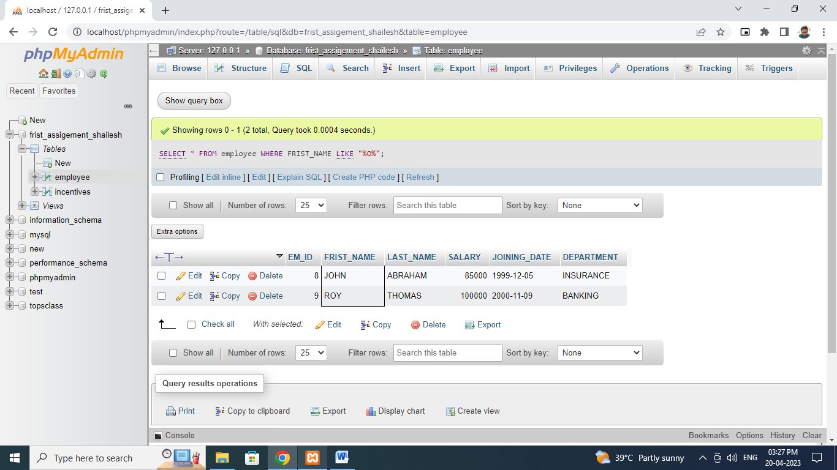

5) Get employee details from employee table whose joining month is “January”.

6) Get department, total salary with respect to a department from employee table Order By total salary descending

SELECT employee.DEPARTMENT,SUM(employee.SALARY) AS TOTAL_SALARY FROM employee

GROUP BY employee.DEPARTMENT

ORDER by TOTAL_SALARY DESC;

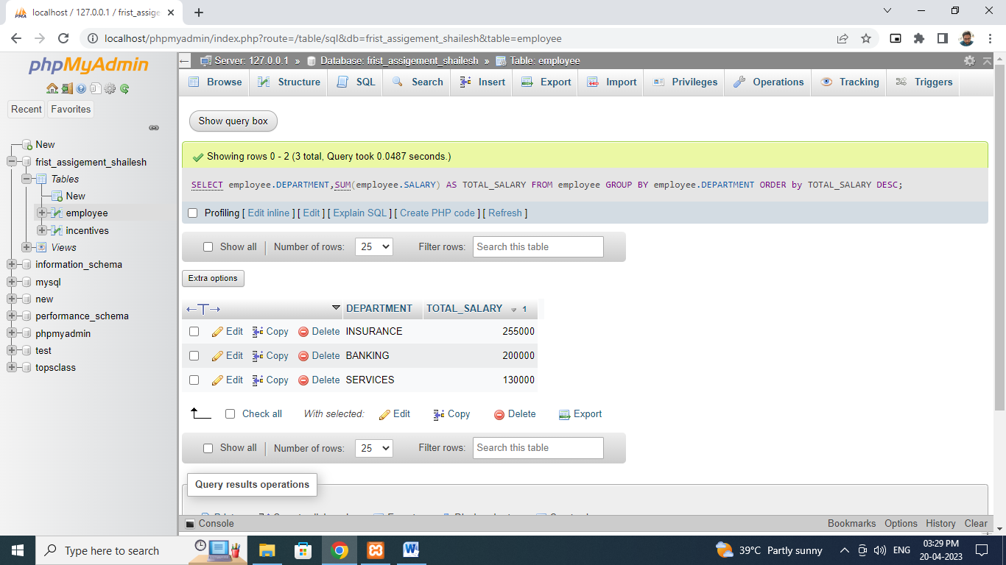

7) Get department wise maximum salary from employee table order by salary ascending?

SELECT employee.DEPARTMENT,MAX(employee.SALARY) AS TOTAL_SALARY FROM employee

GROUP BY employee.DEPARTMENT

ORDER by TOTAL_SALARY ASC;

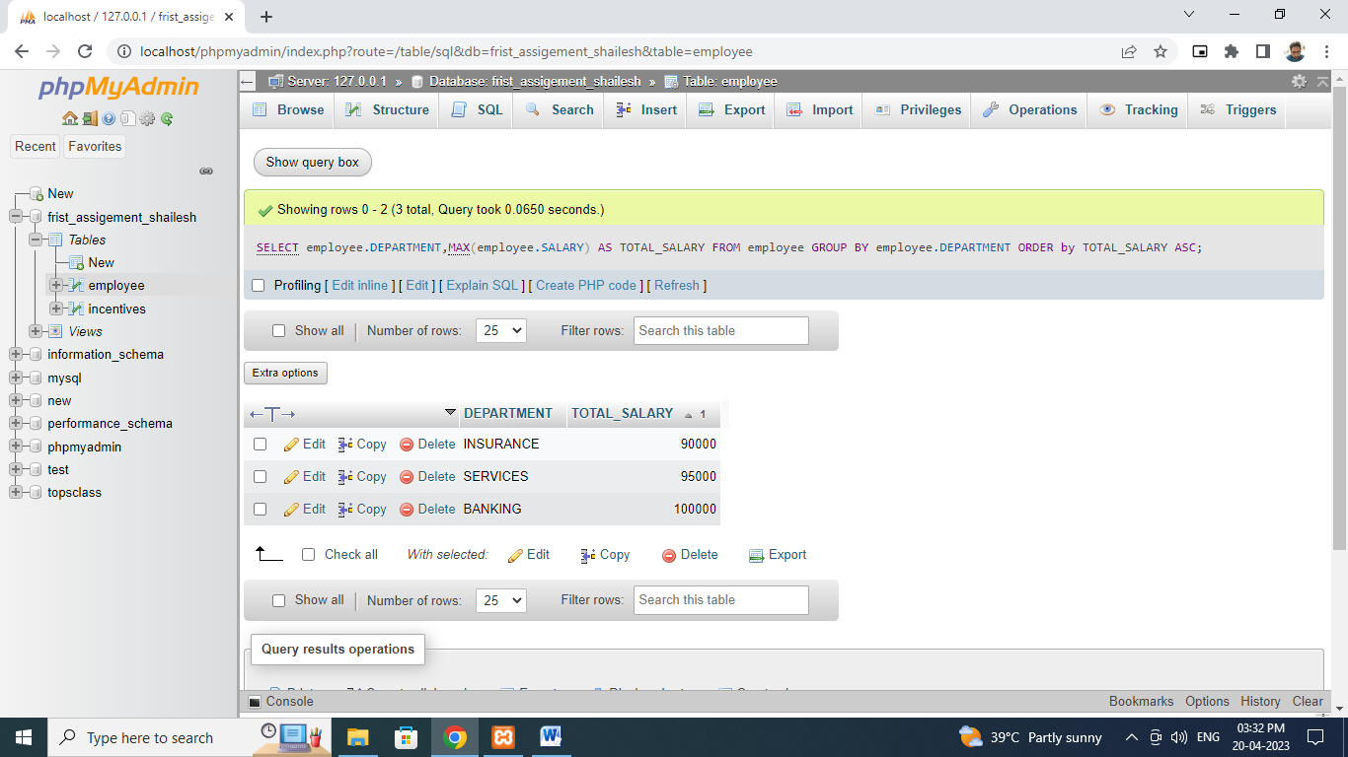

8) Select first_name, incentive amount from employee and incentives table for those Employees who have incentives and incentive amount greater than 3000

SELECT employee.FRIST_NAME,incentives.INCENTIVE_AMT FROM employee

JOIN incentives

ON employee.EM_ID=incentives.EMPLOYEE_REF_ID

WHERE INCENTIVE_AMT>3000;

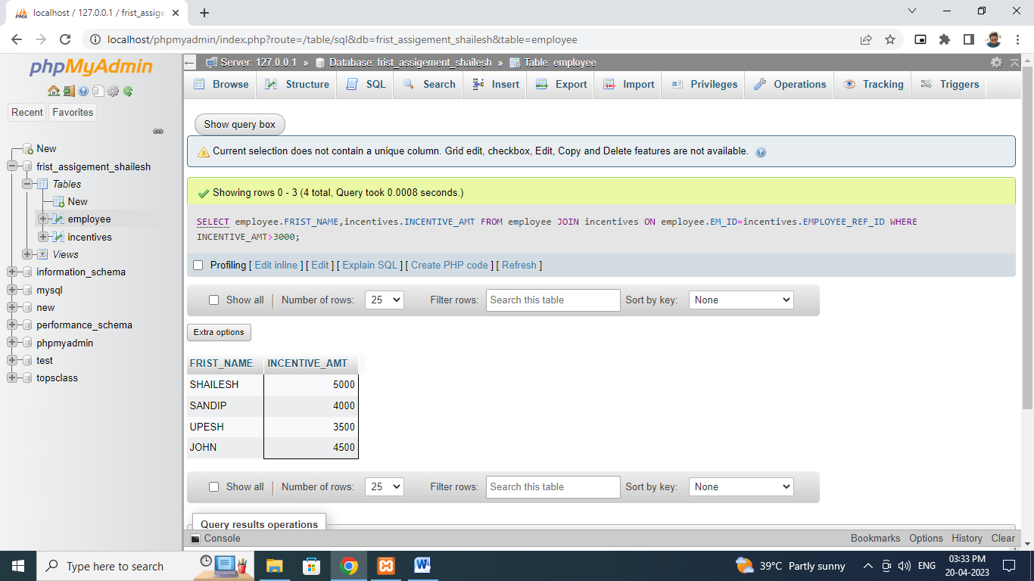

9) Select 2nd Highest salary from employee table.

SELECT*FROM employee

GROUP BY employee.SALARY

ORDER BY employee.SALARY DESC

LIMIT 1,1;

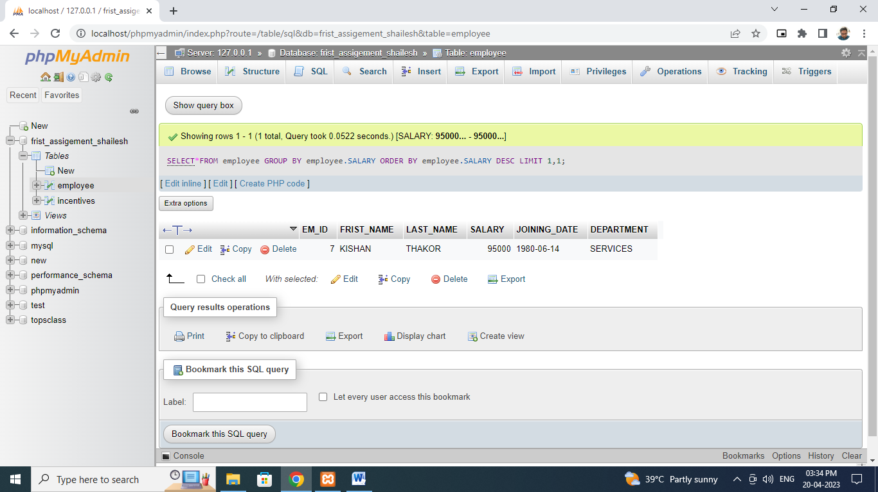

10)Select first_name, incentive amount from employee and incentives table for all Employees who got incentives using left join.

SELECT employee.FRIST_NAME,incentives.INCENTIVE_AMT FROM employee

LEFT JOIN incentives ON employee.EM_ID =incentives.EMPLOYEE_REF_ID

ORDER BY incentives.INCENTIVE_AMT ASC;

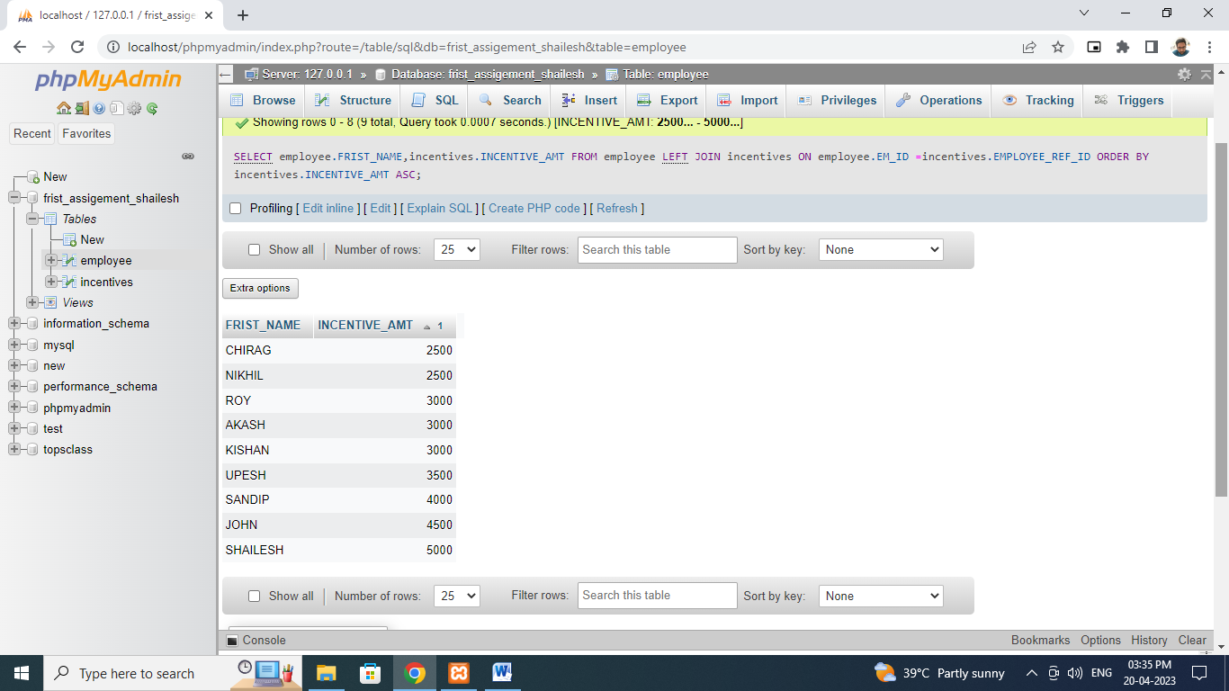

11) Create View OF Employee table in which store first name, last name and salary only.

CREATE VIEW TBL_employee AS

SELECT employee.FRIST_NAME,employee.LAST_NAME,employee.SALARY FROM employee;

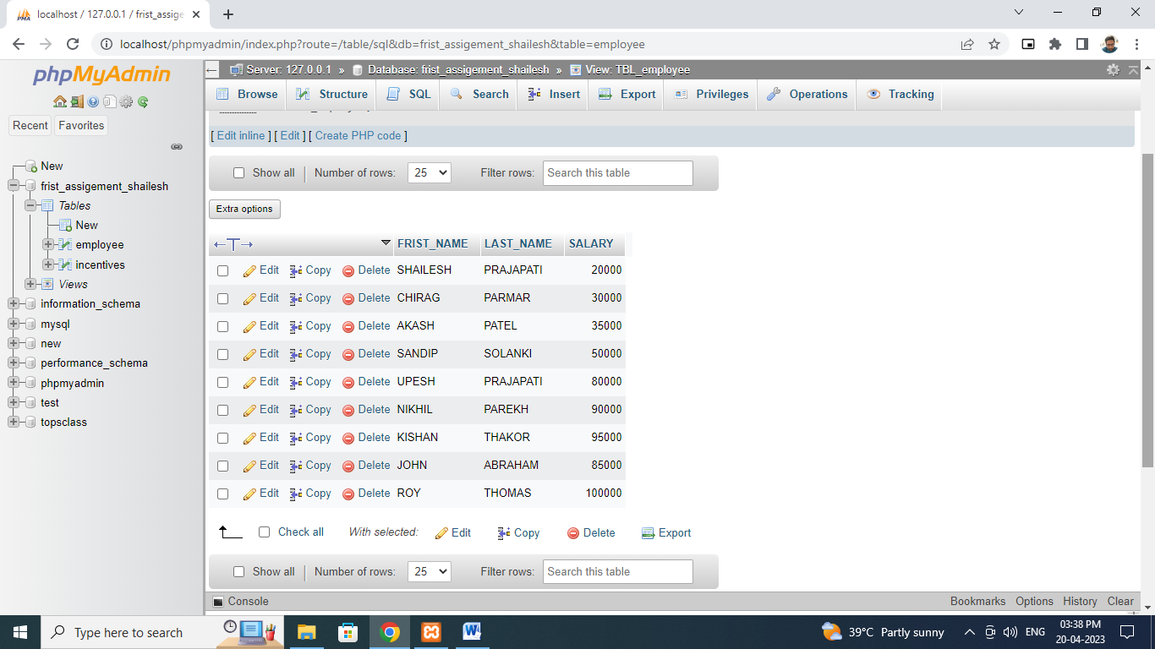

12) Create Procedure to find out department wise highest salary.

CREATE PROCEDURE MAX_SALARY (INOUT SAL INT)

SELECT employee.DEPARTMENT,MAX(employee.SALARY) AS TOTAL_SALARY FROM employee

GROUP BY employee.DEPARTMENT

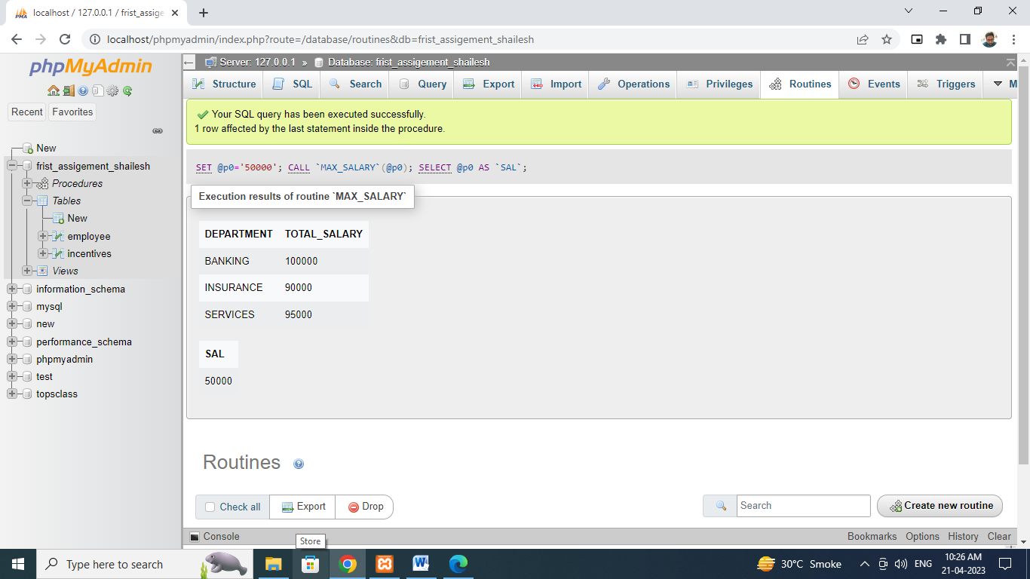

13) Create after Insert trigger on Employee table which insert records in view table.

CREATE TRIGGER EMP_TRIGGER AFTER INSERT

ON employee FOR EACH ROW

INSERT INTO employeetbl VALUES(EM_ID,FRIST_NAME,LAST_NAME,SALARY,JOINING_DATE,DEPARTMENT);

INSERT INTO employee VALUES("","PARESH","PRAJAPATI",45000,"2023-02-01","BANKING");

